VOLUNTEER
APPLICATION FORM
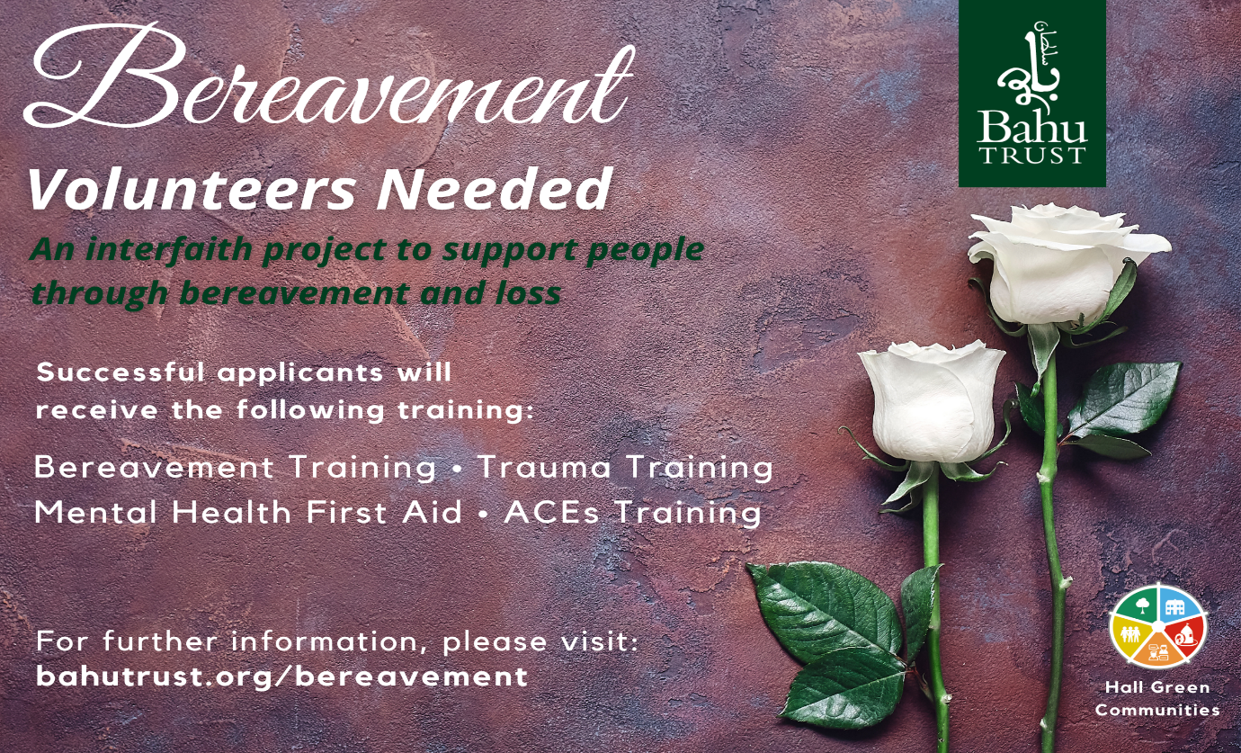

The Bahu Trust is proud to announce an exciting interfaith volunteering opportunity to work with a diverse team to support families in the Hall Green constituency who are going through a period of bereavement as a result of the either COVID-19 pandemic or natural causes.
Volunteering as part of the “Kindness Project”, is a great way to supercharge your social life whilst getting the feel-good buzz of knowing you are making a difference to people’s lives. We will be bringing together volunteers from a diverse range of faiths and backgrounds so that we can tailor our support for the specific needs of our local residents. Volunteers will be provided with high level training in which you will gain life skills and have the tools to be able to identify and meet the needs of individuals who are struggling to cope with loss and are not able to get support which was available in the past through family networks.
The “Kindness Project”, service will require volunteers to be on hand at all times and give a commitment to help and support anyone who calls for help and support. This would require our trained volunteers to be flexible to work out of normal working hours. Volunteers will be part of a team of like-minded people who want to improve the lives of people living with bereavement.
As part of our team you’ll have the support of our responsive Volunteer Manager and receive accredited courses which will train you to be able to support those suffering with loss.
Volunteers will receive the following training and must be able to commit to the below dates;

Online ACES training 2 hours Date 8/01/21
(Adverse Childhood Experiences)

Online Training on Trauma 4 Hours training Date 12/01/21
(How to support individuals suffering from trauma)

Online Bereavement Training 45 Minutes Date 18/01/21
(Loss & Bereavement)

First Aid for Mental Health 1 Day, level 2 training Date 25/01/21
(Level 2 award for first aid training)

How you can help during the coronavirus pandemic
Although physical activities have been suspended, we have reverted to providing support online, however crucial services are still being provided with all social distancing measures. We are now adding a bereavement service to our support network

If that sounds like something you’d like to do, apply to join our Bereavement Project team today and get access to other opportunities to volunteer abroad as well as taking part in exciting events you can join once restrictions are lifted.
Volunteers will be expected to go through DBS checks and will have to sign an agreement to commit to the dates to complete all training provided by the Bahu Trust. Volunteers will be expected to work with a team of volunteers to be able to provide support to individuals upon request and whenever the need arises. Volunteers must have good listening and communication skills and have basic knowledge for recording information keeping in line with GDPR guidelines. Volunteers must also have basic knowledge of using Information Technology as some meetings will need to be organised online.
If this is something you are interested in please fill in the online form or contact Abdullah Rehman on friends@bahutrust.org for a paper application form for you to fill and send back for our consideration.

Please read before completing form
If you decide to write your supporting statement by hand, please make sure that you write clearly and legibly, using a black or blue pen.

Terms and Conditions – The Terms and Conditions contain important information about the volunteer programme so please make sure you read them carefully before signing your application form. You should keep the terms and conditions page for future reference, do not send it back to us. Should you be called to interview, you will be asked to confirm that you have read and understood the terms and conditions.

References – You need to ask two people who are familiar with your personality and experience to complete the reference forms attached to the application form. (These can be posted to us directly by the referee or submitted along with the rest of your application.) Please note that you should get both references from people who are able to give an objective assessment of your suitability for the volunteer programme. For this reason, please do not ask a personal friend, relative, colleague or family friend to act as your referee. Examples of suitable referees might be current or past teachers, employers, sports coaches or religious leaders. Your referees should have known you for at least 1 year.

Further Questions – If there is any aspect of the application that you find difficult to understand, please contact the Bahu Trust:

Call 07737 151326 or
Email friends@bahutrust.org

Please make sure you complete all sections of this application form as thoroughly and truthful as possible. Once you have completed all sections, please either send or email to:
Bahu Trust
17-21 Ombersley Road
Balsall Heath
Birmingham
B12 8UR
friends@bahutrust.org

You must also include:
- Supporting statement (Please see page 4 of application form for details.)
- Completed reference forms (x2)
- Photocopy of passport

Personal Information – Be honest how you answer the questions in this section as they may have serious implications for your safety and insurance. Please make sure to include details of any dietary restrictions (vegetarian, no fish, etc.).

Supporting statement – As it is the only place where you get a chance to tell us, in your own words, about why you should volunteer with Bahu Trust the supporting statement is an important part of your application.
It is important that you try to write the supporting statement yourself and that you take time to think about the four questions we ask you to address.
If typed the supporting statement should be at least one page long (longer if hand-written).

Personal Details
(Please give full details as it is written on your passport)

First Name...................................................................

...... Middle name (s)..............................................

Last name........................................................................................... Gender F M
Address.................................................................................................................................................................
............................................................................................................ Postcode..........................................
Home Tel............................................................................................. Mobile...............................................
Email...................................................................................... Age.............. Date of Birth..............................
Marital Status: Single Married
Do you have a current UK or Irish passport? Yes No
If yes: Date of Issue: .................................... Date of expiry: ....................................................................
Emergency Contact Person

First name: …………………………………… Middle name(s): ……………………………………. ..

Last name: ……………………………………. Relationship: …………………………………………...

Contact Address: …………………………………………….................................................................................

…………………………………………………………………… Postcode: ……………………………………………

Supporting Statement
Please tell us in your own words:

- Why you have chosen to apply to this programme?
- What do you think you can bring to the programme (include personal qualities and any skills and experiences you have gained from any area of your life- work, family or social.)?
- What do you hope to gain from the experience?
- Do you have a passion for community work? [Include experiences you have had already working in the voluntary sector, if any.]

Home Tel: …………………………....... Mobile: …………………………… E-mail:…………………………

Eligibility

In order to be entitled for the programme, you must be able to answer ‘Yes’ to the following questions. If you are unsure of any of them, please call Bahu Trust. (Please write Y or N as appropriate to the question)

Do you have or are you eligible to have a UK passport?
Are you currently a resident in UK?
Are you prepared to follow our volunteer programme requirements?
Are you willing and able to provide two written references?

Are you currently: (Tick one or more boxes, where required)

Working full-time
Working part-time
Studying full-time
Studying part-time
Unemployed
Between jobs
Volunteering in the UK
Other

Which of these best describes your religious beliefs? If you circle “other” in any section, please give details.

Muslim Christiaan Hindu
Buddhist Sikh Humanist
Other

Which of these best describe your background Asian or British Asian Black or British Black White More than one ethnic origin Other

Pakistani African British
Indian Caribbean Irish
Bangladeshi Other Other
African Asian
Chinese
Other

Do you consider yourself to have a major disability or illness? Yes No

If yes, please specify………………………………………………………………………………………………………….

Is there any other skill you have which you feel will be of specific benefits for this volunteer programme?

………………………………………………………………………………………………………………………………………………………….

………………………………………………………………………………………………………………………………………………………….

………………………………………………………………………………………………………………………………………………………….

Application Declaration

I have read and understood all the details given to me by Bahu Trust, and the Terms and Conditions of the programme, I agree to be bound by them and certify that all the statements I have made on this form are true.

Signed: ………………………………………………… Date: ………………………………………………………………

Once you have completed all the sections of your application form and have received your references, you must also include supporting statement, photocopy of passport, please hand it in or send it to: Bahu Trust, 17 – 21 Ombersley Road, Balsall Heath, Birmingham, B12 8UR.

Letter to Referee 1

Dear Sir/Madam,

Applicant’s name:

The person named above is applying for a position on Bahu Trust`s volunteer programme. This form has been given to you as you are someone who is well-known to the applicant. We would be thankful for your reference and assessment of their appropriateness for this volunteer programme.

If you need any further details about the programme or have any other queries, please contact us on 07737 151326 or email friends@bahutrust.org

Please note that you are likely to be contacted by a member of the Bahu Trust team to follow up your reference.

For this reason, we would be grateful if you could provide a day-time telephone number and email address.

Thank you very much for your time and support.

Regards,

Bahu Trust

Reference 1:

Applicant’s name: .......................................................................................................

Your name as referee: ...............................................................................................

Job Title: .........................................................................................................................

Company/Organisation: .........................................................................................

What is your relationship to the applicant: ....................................................

How long have you known the applicant: .......................................................

How would you judge the applicant’s persona and aptness for working with consideration to:?

 | OUTSTANDING | GOOD | FAIR | LOW
TEAMWORK
COMMUNICATION
ENERGY
ENTHUSIASM
FLEXIBILITY
HUMOUR
INITIATIVE
ORGANIZING/PLANNING
RESPONSIBILITY
SOCIABILITY
PATIENCE
KINDNESS

Please provide any additional comments on the applicant’s suitability for the Bahu Trust Volunteer Programme:

............................................................................................................................................................................................................................................

...........................................................................................................................................................................................................................................

Are you aware of any circumstances in the applicant’s background which may make them unsuitable for working on this volunteer programme? Yes No

If yes, please specify: .............................................................................................................................................................................................

.........................................................................................................................................................................................................................................

Signature: ........................................ Date: .........................

Name ..........................................................................................

Contact Address: .....................................................................................................................................................................................................

......................................................................................................................................................... Postcode: ..........................................................

Email: ............................................................Daytime Tel: .........................................................Mobile: ..........................................................

Letter to Referee 2

Dear Sir/Madam,

Applicant’s name:

The person named above is applying for a position on Bahu Trust`s volunteer programme. This form has been given to you as you are someone who is well-known to the applicant. We would be thankful for your reference and assessment of their appropriateness for this volunteer programme.

If you need any further details about the programme or have any other queries, please contact us on 07737 151326 or email friends@bahutrust.org

Please note that you are likely to be contacted by a member of the Bahu Trust team to follow up your reference.

For this reason, we would be grateful if you could provide a day-time telephone number and email address.

Thank you very much for your time and support.

Regards,

Bahu Trust

Reference 2:
Applicant’s name: .......................................................................................................

Your name as referee: ...............................................................................................

Job Title: .........................................................................................................................

Company/Organisation: .........................................................................................

What is your relationship to the applicant: ....................................................

How long have you known the applicant: .......................................................

How would you judge the applicant’s persona and aptness for working with consideration to:?

 | OUTSTANDING | GOOD | FAIR | LOW
TEAMWORK
COMMUNICATION
ENERGY
ENTHUSIASM
FLEXIBILITY
HUMOUR
INITIATIVE
ORGANIZING/PLANNING
RESPONSIBILITY
SOCIABILITY
PATIENCE
KINDNESS

Please provide any additional comments on the applicant’s suitability for the Bahu Trust Volunteer Programme:

............................................................................................................................................................................................................................................

...........................................................................................................................................................................................................................................

Are you aware of any circumstances in the applicant’s background which may make them unsuitable for working on this volunteer programme? Yes No

If yes, please specify: .............................................................................................................................................................................................

.........................................................................................................................................................................................................................................

Signature: ........................................ Date: .........................

Name ..........................................................................................

Contact Address: .....................................................................................................................................................................................................

......................................................................................................................................................... Postcode: ..........................................................

Email: ............................................................Daytime Tel: .........................................................Mobile: ..........................................................

Terms and Conditions

Acceptance on to the Programme

To apply for the volunteer programme, you must put forward a completed application to Bahu Trust. Your approval on to the programme will be judged on your eligibility, your written application, interview and two references.
Confirmation of your place will be made by email or by notifying through a phone call.
Bahu Trust reserves the right to discard any applicant at any phase of the application process. In such cases warning will be made in writing via e-mail. The purpose of this type of programme is to provide volunteers with experience and accredited training for personal development.

Training Days

All volunteers are required to attend training before the volunteer programmes starts.

Personal information

Your personal records will be treated confidentially.
Bahu Trust reserves the right to speak freely about your health, well-being and conduct whilst on the volunteer programme. Please inform a member of the team if you would prefer us not to do so.

DBS Check

Due to some of our projects including work with vulnerable adults all participants will be CRB checked. Any offences on participant’s records will be looked at on an individual basis and will not result in a definite rejection on the volunteer programme.

All records gained from the CRB checks will be dealt with confidentially and no details will be released.

Recordings and Pictures

- We will be documenting this volunteer programme and all participants must agree with their requirements regarding filming, interviews etc.
- All work orientated pictures taken on this volunteer programme will be given to Bahu Trust towards the end of the programme for Bahu Trust’s usage for promotion and publicity for future events.

Rights and liabilities

1. Any images and video taken of me while on the programme, I waive any rights for Bahu Trust to use them.
2. I will not hold Bahu Trust, its partners or employees liable for any loss, damage, personal injury, delay or expense suffered or incurred by me for any reason.
3. Bahu Trust, its partners or employees may, without liability or expense to themselves, take whatever action they consider correct with regard to my health and safety.
4. I indemnify, without limitation, Bahu Trust, its partners or employees, against any loss or damage suffered by any of them or any claims made against any of them as a result of any breach or negligence by me during my participation on the programme.

