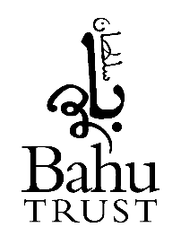
Nikah
Application Form

BRIDEGROOM DETAIL

Name of Bridegroom ____________________________ Name of Father ______________________________

Address: ________________________________________________________________________________

Date of Birth ______________________________ Religion _____________________________________

Marital Status of Bridegroom: Bachelor Existing Wife Widow Divorced

BRIDE DETAILS

Name of Bride ____________________________ Name of Father ______________________________

Address: ________________________________________________________________________________

Date of Birth ______________________________ Religion _____________________________________

Marital Status of Bride: Maiden Widow Divorced

Al-Mahr Amount (Dowry) £ ____________ Pay at once Deferred:

Name of Attorney/Wakeel: (if appointed by the Bride) ____________________________________________

Address: ________________________________________________________________________________

WITNESS DETAILS

Name of Witness 1 __________________________ Name of Witness 2 ______________________

Address: __________________________ Address: ______________________

__________________________ ______________________

Postcode _________________ Postcode ______________

VENUE DETAILS

Date of Nikah _____________________________ Time of Nikah ____________________

Nikah Location: Sultan Bahu Masjid House Hall/Venue

Language Preference English Urdu Arabic Bangla

Location Address: ________________________________________________________________________________

Contact Person ______________________________ Contact Number ______________________

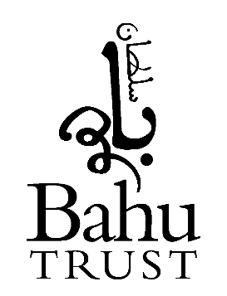

Nikah Checklist for Registration

at Sultan Bahu Masjid

Please ensure that all details on application form are complete:

- Full name, date of birth, address and name of father, of both bride and bridegroom.
- Two witnesses with their addresses. One witness to representing the bridegroom and the second witness representing the bridegroom.
- Please ensure that all spellings are correct on application form
- Amount of Mehr set (dowry). This is a compulsory act in Nikah.
- Date and place of Nikah.
- Contact details of who the masjid should liaise with

Identification Documents

- Scan of passport copy for both bride and bridegroom.
  - If you are an oversees resident, you must have at least minimum 1-month valid visa on your passport
  - If you do not have a passport, then a driving license or birth certificate will suffice
- Scan of proof of address of bride and bridegroom. (driving licence, utility bill etc) one ID document is sufficient.
- Divorce certificate - if either the bride or bridegroom have previously been married. Without this we will not be able to proceed with the nikah ceremony. Depending on the situation we will either need to see the divorce certificate from the British courts or from an Islamic sharia council

Fee

- The recommended contribution for conducting the Nikah ceremony is £250
- Fee can either be given on the day of the Nikah or can be paid in the office in advance.
- If this amount is not manageable, please do not hesitate to let us know, we would not wish for anyone to delay their Nikah on the basis of affordability.

Please return completed form to the Bahu Trust reception or to the Masjid Imam

